Worksheet 2 – Web Design & Development – Y2Sem1

We want to refine the start we made in week 1 where we created some very basic pages for the Clubs and Societies website.
At the end of this worksheet, your clubs page should look like this:

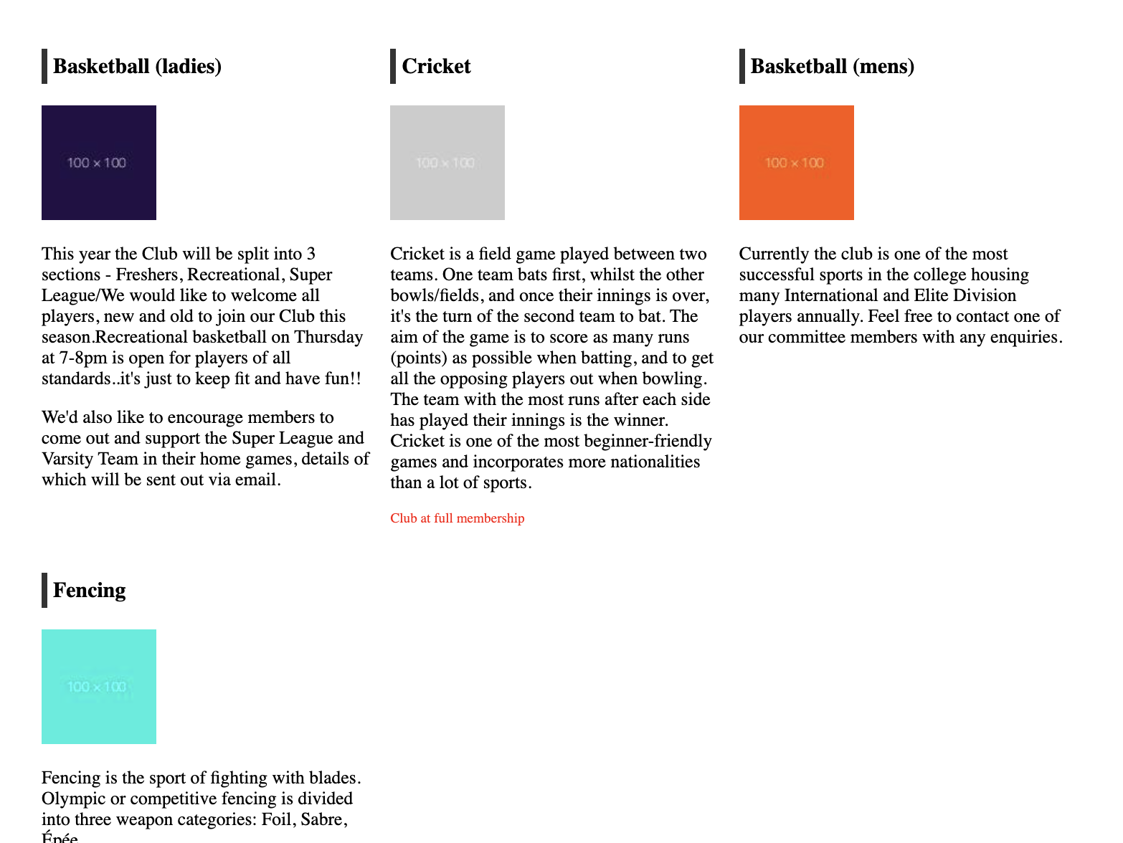

This week - we want to improve those basic pages to add some HTML5 (now known just as HTML) syntax that will improve the page from the point of view of some basic accessibility, search engines and general layout.
If you have already added some of the elements and styling mentioned below – that’s fine – just carry on with that.
Make sure you look to the lecture notes/search online - for the answers you are looking for.

Make sure you save your work on your OneDrive or remote location
- within your existing directory structure create a directory called Lab2 – copy over the existing work from Lab 1. We want to improve it.
- so you should have something like /Year2/WDD/Lab2 or similar

Task A – head and footer improvements

1. Add page meta element to the header of index.html
Add a HTML meta element in the <head> section of the file; This doesn’t appear in the browser but is actually for the search engines
- add meta tag containing the following - if you have not already added them:
  - <meta name='description' content='your content goes here'>
  - the 'your content goes here' should be replaced with content relevant to your page - it sums up the content of the page for search engine results pages (SERPS) - it should really be no longer than 160 characters, if it is longer it will just be chopped off on the results page.
Review
Do a search on Google for clubs and societies from other colleges. Look at what the description says? Does the description tell you what the page is about? Would the description make you click on that link? Do you now want to modify the meta description?

2. Add lang attribute, meta charset, meta viewport to the header of index.html
- add lang='en' to the <html> element
- add meta tag containing charset to the header
  - <meta charset='utf-8'>
- add meta tag containing viewport to the header
  - <meta name="viewport" content="width=device-width,initial-scale=1">

Review
Make sure you know again the purpose of the meta description. Ask your colleagues to review your meta descriptions. Do they seem to be appropriate?

3. Add the nav element around the main navigation
In the the main menu in the header - the unordered list - surround this with <nav> element. This is an example of a HTML5 element defining a set of navigation links to the browser.

4. Add the footer element around the main navigation.
If you currently have a <div> and <p> elements around your footer at the moment – then remove these and replace with the <footer> element.

5. Recreate Steps 1 thru 4 above in all of the pages of your site.
- Make sure that you update the <head> section of all of your files as well as <nav> element.
- Make the meta description tag relevant to the individual pages
- Add the nav
- Add the footer

Review
You have just added multiple meta tags to each file of your website.
- What is the downside to this constant editing and adding to separate files?
- What structure in the files would make this easier?

Task B - content/look and feel improvements

6. To Clubs page - add some content.
The Clubs page gives a short overview of all clubs in ATUS. It will include club name, short description (say max 150 words or so) and image.
Use some of the basic HTML5 elements we talked about - specifically main, section, article, header, footer - to structure your overview page for clubs. You may have already added these – if not – add them now.
Add maximum of 4 different clubs – Basketball (ladies), Cricket, Basketballl (mens), Fencing.
Add in <a> and <p> elements where relevant.
Remember what we said in previous Lab about making the content appropriate to the page – give some thought here to what is relevant to each particular page – and the function of each page on the site! There is no point having a page on the site if we question – why is it there? (this is where planning the site initially with a sitemap, wireframe – is so useful at an early stage of the process)
If you cannot find appropriate image - use an image generation site such as https://dummyimage.com - gives you a url schema so that you can insert blank sized images. Again for your project – you might use this at very early stages – but part of your content discovery – will be thinking about appropriate imagery for each page.

7. Add some styling to centre the site
The site is currently not centred. Add the following code to the top of style.css
html, body {
width: 960px;
margin: 0 auto;
padding: 0;
}

Review
- Take out auto – refresh page. What happens?
- Change border to 20px – what happens?
- In our clubs page – the h1 for the main title page is is different size from the other h1’s on the page – why is this?

8.Add a message to cricket club to show that it is full
Add the following to the cricket club to the end of the cricket club description
<p id=’full’>Club at full membership</p>
- Add relevant selector to style.css so that font for this is red and the font size is slightly smaller than the main text.

9.Style the article h1 element
Let’s target the article level h1 elements on the contact page. Add this to your style sheet.
article h1 {
padding:5px;
border-left:5px solid #333;
}
This means that we are specifically targeting only the h1 elements contained with article.

10. Position club image to left of description
- Image should be under the name of the club
- Float the image to left; the description text should be on the right
- There should be padding to the right of the image so the text has room to breathe.

11. Display clubs over 3 columns
At the moment when we display our clubs – they display one by one down the page. We want to display the club info so that they are displayed columns across the page.

Add the following code to your stylesheet

article {
padding:5px;
display:inline-block;
}
.club {
width:290px;
vertical-align:top;
}
Now target each <article> in the clubs.html file with this ‘club’ class.
Review
Are the clubs being displayed across the page? If not – chat to the person beside you and work out what the problem is…

12. Implement a ‘Read more’ Link for each club
- Add a <a> element so that each club has a link to a separate page (e.g. basketball-mens.html,cricket.html etc)
- Style the link to look like a button
13. Now replace ‘Read More’ link with a different hover style access to each individual club page.
So the ‘Read More’ link works and is fine – but we want something else.
When the user hovers over the <article> element – we want the whole article to change background color on hover – and the link to the club page.
Do a search on how to do this – things you are looking out for include the following:
- Add hover background-color to article
- Remove text-decoration on <a> element – the text of the description should NOT look like a link (remove blue colour and underlining)

